* **EDUTAINERS**

**Series – I Specialist of Science Date: 06/01/18**

**Bio Ch#14(2nd Half) T1 1st Year Time: 1hr 15min Marks:40**

**Name: ____________________________**

**(OBJECTIVE)**

**Q.1: Choose the correct answer. (10)**

1. **The casparian strips are present in:**

(A).Cortex cells of roots (B). Endodermis cells of roots

(B). Cells of pericycle (D). Cells of Phloem

1. **Lymph most closely resembles with:**
2. Blood (B). Plasma (C). Interstitial fluid (D). Urine
3. **Hydathodes are associated with:**

(A). Transpiration (B). Guttation (C). Conduction (D). None

**iv. According to pressure flow theory, which of the following serves as sink?**

(A). Leaves (B). Stem (C). Roots (D). None

**v. The process that most likely/directly enables a root hair cell to absorb minerals by active transport and enables a muscle cell to contract is:**

(A). Circulation (B). Excretion (C). Respiration (D). Assimilation

**vi. Which of the following processes cause substances to move across membranes without the expenditure of cellular energy?**

1. Endocytosis (B). Active transport (C). Diffusion (D). None

**vii. Cardiac muscle can be distinguished from other muscle fibers because cardiac muscle:**

1. Contain only actin (B). Voluntary in action (C). Lacks regular arrangement of sarcomeres

(D). has intercalated discs

**viii. Which of the following is not true of guard cells?**

(A). they are present in the epidermis of leaf.

(B). they are connected with plasmodesmata with other epidermal cells

(C). they contain chloroplasts

(D). they are kidney shaped

**ix. Which of the following is true about mammals?**

(A). they have right aortic arch only (B). they have left aortic arch only

(C). they have left and right aortic arches (D).they do not have aortic arch

**x. Blood is _________ tissue:**

(A). Connective (B). Muscular (C). Nervous (D). None

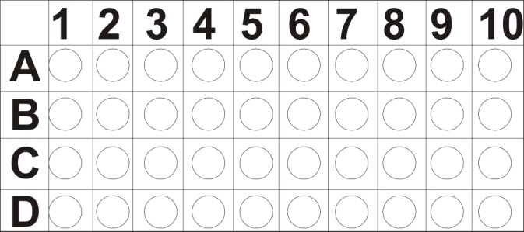

**SUBJECTIVE**

**Q.2: Answer the following short questions. (11 x 2 = 22)**

1. **How is lubb Dubb sound produced?**
2. **What is leucemia?**
3. **Difference between stroke and hemorrhage.**
4. **What is myocardial infarction?**
5. **How blood can move in veins?**
6. **What are blue babies?**
7. **Different between AV node and SA node.**
8. **Define blood pressure.**
9. **What is electro radiogram?**
10. **What are platelets?**
11. **Difference between active and passive immunity.**

**Q.3: Long Questions (4 + 4 = 8)**

1. **Give the Function of blood.**
2. **What is lymphatic system?**